PROJECT DEVELOPMENT PHASE 4
ACL Configuration
Script-Controlled ACL – Restrict Record Access Based on Field Value
Project Details | Values
Date | 30 September 2026
Team ID | SWTID-2026-8983
Project Name | Script-Controlled ACL – Restrict Record Access Based on Field Value
Phase | Phase 4 – ACL Configuration
Maximum Marks | 5 Marks

Team Role | Team Member
Team Leader | NITHYA SREE S
Team Member | RAMASRI D
Team Member | PRATHISHA S
Team Member | MEGALA M
Team Member | MANJARI T

1. Objective
Configure the ServiceNow Access Control record for the target table and the approved operation.

2. Phase Workflow
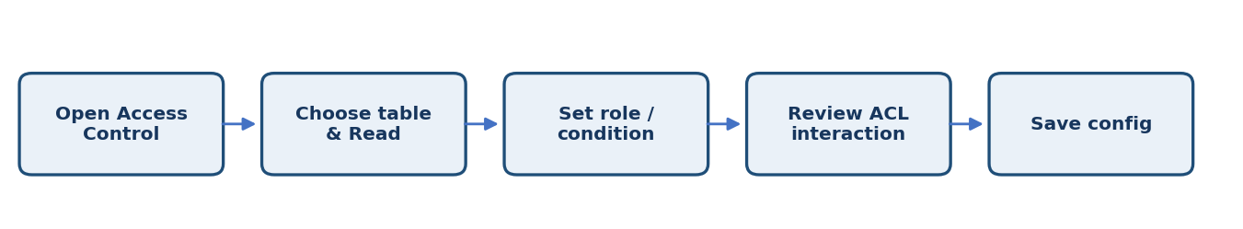

3. Activities / Scope
- Create or update the target table's Read ACL as specified.
- Configure roles and conditions according to the approved matrix.
- Check ACL scope, order, inheritance, and existing rules.
- Avoid broad roles or conditions that unintentionally grant access.
- Save the configuration in the development instance.

4. Sprint Backlog & Estimation
Sprint | Story ID | Requirement | User Story / Task | Story Points | Priority | Team Members
Sprint 4 | US-401 | Create Read ACL | Set the target table and Read operation. | 2 | Medium | Project Team
Sprint 4 | US-402 | Configure criteria | Apply approved roles and conditions. | 3 | High | Project Team
Sprint 4 | US-403 | Review ACL interaction | Check inheritance and existing access rules. | 2 | Medium | Project Team

Total Estimated Story Points: 7

5. Testing / Review Template
Test Case ID | Scenario / Steps | Expected Result | Actual Result | Status
TC-01 | Verify that the ACL is attached to the intended table and operation and that no unrelated table or operation was changed. | Expected behavior matches approved requirement. | ________________ | Pass / Fail
TC-02 | Record observations, issues, and evidence for this phase. | No unresolved blocker before phase sign-off. | ________________ | Pass / Fail
TC-03 | Review phase deliverables with the responsible team member. | Deliverables reviewed and approved. | ________________ | Pass / Fail

6. Deliverables
- Configured ACL record
- Configuration screenshots
- ACL review checklist

7. Team Review & Sign-off
Review Item | Details
Prepared by | Megala M / Project Team
Reviewed by | ____________________________
Approval / Date | ____________________________
Remarks | ________________________________________________

